Name: ______________________

**What’s Going on in this Text Feature:**

**Direction:** Take a moment to do some quiet looking. Then respond to our VTS questions as you think about this text feature:

1. What’s going on in this text feature?
2. What did you see (or read) that made you say that?
3. What more can you find?

Write your thoughts on the lines. There’s more room on the back. Be sure to reread your work.

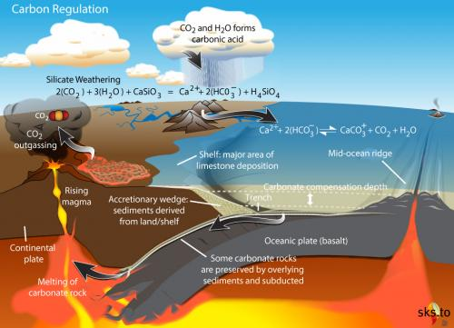

[This Photo](https://skepticalscience.com/print.php?g=84) by Unknown Author is licensed under [CC BY](https://creativecommons.org/licenses/by/3.0/)

_____________________________________

_____________________________________

_____________________________________

_____________________________________

_____________________________________

_____________________________________

_____________________________________

_____________________________________

_____________________________________

_____________________________________

_________________________________________________________________________________

_________________________________________________________________________________

_________________________________________________________________________________

_________________________________________________________________________________

_________________________________________________________________________________

_________________________________________________________________________________

_________________________________________________________________________________

_________________________________________________________________________________

_________________________________________________________________________________

_________________________________________________________________________________

_________________________________________________________________________________

_________________________________________________________________________________

_________________________________________________________________________________

_________________________________________________________________________________

_________________________________________________________________________________

_________________________________________________________________________________

_________________________________________________________________________________

_________________________________________________________________________________